1. What does chart.yaml file contains? Ans. It contains a chart description. (it’s meta data about chart)

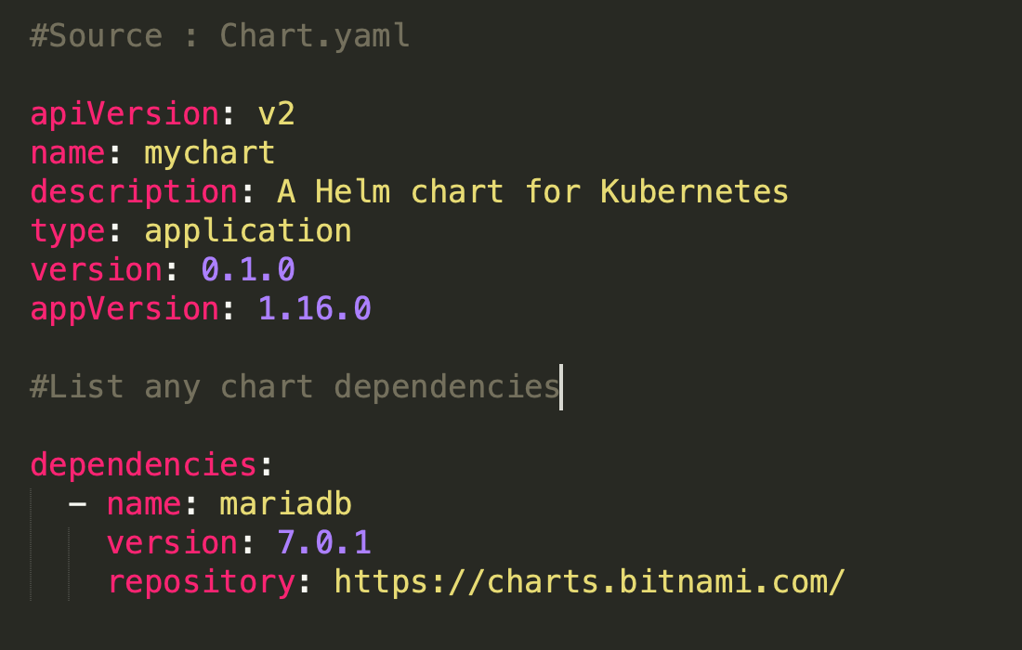

2. How to insert a release name into YAML template? Ans. {{.Release.Name}}

3. How to [test the template rendering in Helm without installing](https://www.cyberithub.com/how-to-install-iperf-network-throughput-test/) anything ? Ans. helm install --debug --dry-run ./testchart

4. How does the basic structure of Helm Chart looks like ?

Ans. It looks like below:-  
package-name/  
charts/  
templates/  
Chart.yaml  
LICENSE  
README.md  
requirements.yaml  
values.yaml

5. What is the [command to create](https://www.cyberithub.com/create-a-self-signed-certificate/) a Helm chart ? Ans. helm create <chart-name>

6. How to Inspect a values file in Helm Chart ?

Ans. helm inspect values

7. Which [default file is used to pass the values](https://www.cyberithub.com/change-default-umask-values-permanently/) in Helm Chart ? Ans. values.yaml

8. How to show all the available charts from Artifact Hub ?

Ans. helm search hub

9. How to show "wordpress" charts from [local repository](https://www.cyberithub.com/how-to-setup-local-yum-repository-on-centos/) ?

Ans. helm search repo wordpress

10. How to Install or upgrade helm ?

Ans. helm upgrade --install <release name> --values <values file> <chart directory>

11. How to Check if there is any error in the Helm Chart ? Ans. helm lint ./<chart-name>

12. Which function returns file bodies as a YAML Map ?

Ans. Files.AsConfig

13. Which Function can be used to iterate over the Line in a File ?

Ans. Files.Lines

14. Which field provides information about [Kubernetes Cluster](https://www.cyberithub.com/3-easy-methods-to-deploy-create-pods-in-kubernetes-cluster/) Capabilities ?

Ans. Capabilities

15. Which is having the higher precedence between --set option and default values.yaml file ? Ans. --set is having higher precedence over default values.yaml file.

16. Can we declare more than one livenessProbe handler ?

Ans. No

17. Which function can be used to quote the Strings ? Ans. quote function

18. Which function can be used to repeat the String a given number of times ? Ans. repeat function

19. How to make sure a default value is used in the template in case the given value is Omitted ?

Ans. By providing a default value through default function.

20. Which file is used to pass all static chart values ? Ans. values.yaml

21. Which function can be used to lookup resources in a running cluster ?

Ans. lookup function

22. What is the return [type of lookup function](https://www.cyberithub.com/c-plus-plus-template/) ?

Ans. A dictionary function

23. Which of the Helm commands does not contact Kubernetes API ? Ans. helm install | update | delete | rollback --dry-run

24. Which function takes a list of values and returns the first non-empty one ?

Ans. coalesce function.

25. Which function can be used to remove white space from both sides of the string? Ans. trim function. {{ - Hello - }}

26. What will be the output of below helm function ? repeat 3 "hello" Ans. hellohellohello

27. How to download and look at the [files for a published chart without installing](https://www.cyberithub.com/solved-errors-in-crontab-file-cant-install/) it ?

Ans. helm pull chartrepo/chartname

28. What are the different [types](https://www.cyberithub.com/inheritance-concepts-and-its-5-different-types-in-python-with-examples/) of Charts ?

Ans. There are two types of Charts: Application and Library.

29. What will be the default chart type if we do not use "type" field ?

Ans. Application Chart

30. Can an application chart be used as a Library Chart ?

Ans. Yes

31. How to Use Application Chart as Library Chart ?

Ans. This can be done by setting the type to "library".

32. Which of the different fields needs to be specified for dependencies? Ans. There are three fields required for dependencies: - a) name b) version c) repository